The Views of Employers Students and their Parents

This report was commissioned by the then Department of Education, Employment and Workplace Relations.
Work Exposure and Work Placement Programs in Schools involving Group Training Organisations

MAY 2014

1 Introduction

In October 2012, Group Training Australia was commissioned by the then Department of Education, Employment and Workplace Relations (DEEWR) to undertake a project to identify the characteristics of good practice in facilitating work placements for school students, based on the work group training organisations (GTOs) do with schools and students in Years 9-10 and Years 11-12.
The aim of the project was to learn from the experience of GTOs in order to develop good practice work placement principles. Group Training Australia was asked to:
- undertake a series of twenty case studies highlighting a variety of different work placement and work exposure approaches (with different industries, locations and target groups); and
- develop ‘good practice principles’ for work exposure and work placement.
In October 2012, GTOs involved in working with schools were asked to complete a survey to gather initial data on the type of involvement they have with schools. The data collected built on an earlier survey conducted by GTA National in July 2011. GTOs were also invited to nominate to be part of case study research.
Twenty good practice programs were selected from across a mix of locations, industries and types of programs. A team of researchers was engaged to interview each of the twenty good practice GTOs along with some of the schools they work with to put together the case studies.
To complement these interviews three online surveys were developed to garner the views of employers, parents and students involved in programs focused on work exposure and work placement with the case study GTOs. The surveys were designed to provide specific data for the case studies as well as general information on employer, parent and student views on good practice for work exposure and work placement programs in schools.
Case study GTOs were asked to encourage the employers, parents and students involved in their programs to fill out the survey. The surveys were undertaken during February – May 2013. Responses were received from 52 employers, 46 parents and 35 students.
The following analysis summarises the results of these online surveys.

2 Employer Views
Respondents
52 employers responded to the survey on work exposure and work placement programs in schools involving group training organisations (GTOs). They covered a wide range of industries including construction, automotive, manufacturing, childcare, mining and tourism. They also ranged in size – roughly a third were small employers (under 10 employees), a third were medium (10-50 employees) and a third were large (over 50 employees).
Involvement in school-based programs
More than half the respondents had been involved in school-based programs with GTOs for more than four years. The most common form of work exposure or work placement activity that they had participated in was short-term work experience (78.4%), followed by providing a school-based apprenticeship or traineeship (63%). About half of the respondents provided a work placement as part of a work readiness program.
The main reasons employers become involved in work exposure or work placement programs was to promote careers in their industry (75%), to assist students develop relevant skills in a practical environment (69%) and to develop student understanding about work (65%). About a third wanted to assist disadvantaged students. See Figure 1 below.
Figure 1: Employers motivation for being involved in school-based programs

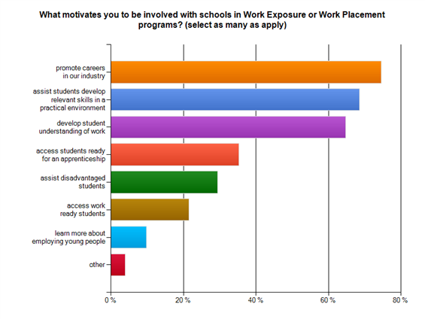
Value of involving employers
Employers were asked what added value they brought to work exposure and work experience programs, compared to relying on schools to provide all the learning.
A major theme in the responses was the value employers provide in giving students real life practical experience, including an understanding of how a business operates, the pressures involved and expectations of employers. Employers said that they help develop confidence and employability skills through exposure to customers, work teams and workplace rules.
The practical real life experiences they gain in areas such as: problem solving, working in a team environment and time management.
It’s the actual immersing in the day to day running of a complex organisation, accepting a responsibility and following it through to completion, while doing this in a supportive scaffolding environment.
Employers said that contact with workplaces also gives students the opportunity to use their school learning applied in real settings. It makes school work real and tangible, it makes sense of the theory and validates learning.
Provision of a workplace environment and experience to help provide some students with the opportunity to ground what they are taught at school with something real, tangible and confidence boosting.
It can also reinforce what schools are trying to teach and puts their learning in a real time perspective.
Employers considered that work exposure and placement activities also allow students to get a feel for an industry which will help them make a more informed decision when it comes to choosing a career, including understanding the sorts of occupations available within a particular industry.
They are able to get a feel for the industry first hand. Their eyes are opened fully to the whole experience.
It is also an opportunity to see if they like or are suited to the career they have chosen.
A few employers noted the value to their own organisations in identifying and trialing future employees.
Value of using a facilitator
Employers were asked how much value there is in having an organisation like a group training organisation promote and organise employer involvement.
The large majority of employers (90%) saw significant value in using a coordinating body like a GTO. GTOs help with compliance and accountability, take the hassle out of finding suitable students, and provide support to students. Several employers said it was absolutely necessary or essential to have a facilitator like a GTO.
Provides one less worry with ensuring compliance with pertinent codes of practice, legislation and current educational requirements.
With the everyday demands on business, time lines and constraints, I believe it is important to have a group training organisation in place to make all the pieces come together for the benefit of the student and the business together.
High value. These operations need a body that can oversee and coordinate large scale operations in an organised and responsible manner.
This is very beneficial. They have an understanding of the student prior to them being placed in my workplace. They have links to additional information that I may not have.
They can do all the running around for me, saves me time and money. They also talk to the kids before so that they roll up ready to go

Work exposure activities
Employers felt the most valuable work exposure activities they provided were short term work experience and where they were actively involved in assisting young people with their literacy and numeracy skills. But, apart from ‘visiting the school to give talks’, which was seen as ‘fairly valuable’ by most employers, all other employer activities were seen to be highly or extremely valuable. See Figure 2 below.

Figure 2: Employers views on value of different work exposure activities
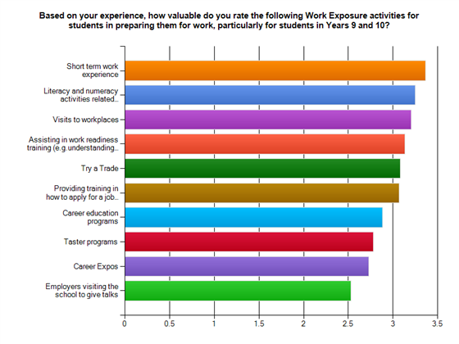
Role of employers in Years 9 and 10
Employers were asked what role they could or should have in Year 9 and 10 work exposure programs.
The most common role employers saw themselves as providing was giving the students a taste of the working environment and helping them understand what work is like and employer expectations in the workplace. Some employers wanted to emphasise that work placements are not about free labour, but rather exposing students to the full variety of work within a workplace.
Work exposure programs should assist with giving Year 9 and Year 10 students a realistic insight into the day to day involvement in the work force.
The student is involved in the day to day activities that are happening; I do not accept that the student should be just sweeping floors and ‘lackey’ jobs.
Some saw the employer role extending to mentoring and some employers felt they also had a role in motivating students to want to work in the future, giving them the desire to achieve at school.
Mentoring and guiding within the workplace as far as possible-clarifying and explaining procedures and policies to an appropriate level.
Giving them a clear understanding of the expectation of employers by their staff. Managing time keeping, required paperwork, encouraging them in their school based learning, especially English and Maths.
Giving students an insight into particular industries and helping them decide on different career paths was another role employers saw themselves as being able to provide.
The earlier a student identifies a career the better prepared they will be.
Safety was a strong theme. Employers emphasised the importance of providing a safe environment to learn and enforcing a focus on workplace health and safety.
A few employers pointed out that they choose not to take students from the younger age groups for safety and/or motivation reasons.
We don't generally take on students in these grades due to the nature of the work environment and the ability of students to follow instructions and usually, their lack of motivation. At this age we have found that the majority of students are not prepared for the real world and generally don’t have great work ethics.
Length of time for work placement
In order to develop general skills and an understanding of the workplace, most employers felt 2 – 4 weeks were required. Some said two weeks did not offer enough time.
…. at least a month, a week of work experience doesn’t convey an industry at all.
Long enough to actually begin and complete a set task so they actually learn the skills involved, otherwise they end up being the coffee maker and the shredder for the office.
Several said that if placements were one day a week, they would need to be spread over six to twelve months in order to be valuable. One day a week did not suit all workplaces, however, some prefer blocks of time.
I don't like the one day a week system, in order for a student to understand the demands of a job they need a block period, two weeks plus.
In order to reinforce theoretical learning with practical skills (ie become competent), most employers said it would take 6-12 months, depending on the occupation and the student.
3 Parents Views
Respondents
46 parents responded to the survey. Their children were mainly enrolled in Years 11 or 12 (79% of cases). The remaining 21% were enrolled in Year 10 and there were none in Year 9.
Types of activities
The most common form of work exposure or work placement activity that their children had participated in was short term work experience (58% of all responses). This is not surprising as more students across Years 10-12 would have had the opportunity to participate in work experience, than have accessed work placement through VET or apprenticeships.
44% of parents also reported that their children had received training in applying for a job and in interview skills – a strong feature of GTO partnerships with schools in Work Exposure activity. See Figure 3 below.
Figure 3: Parent knowledge of the nature of work exposure or work placement their student child was involved in

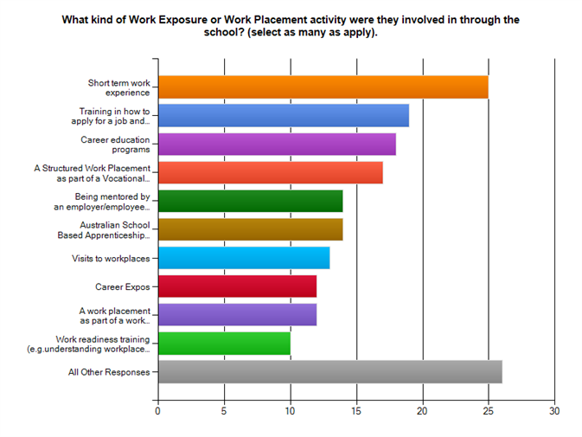
More than 80% of parents had received information about the Work Exposure or Placement program before their child participated. In some cases, schools, and in other cases, group training organisations, provided this information to parents, either through written material or briefing sessions held prior to the activity.
Parents almost universally considered that the Work Exposure and Work Placement programs provided for their children were extremely valuable experiences. 85% of respondents indicated that they thought these programs were ‘extremely valuable’ while only 4% thought they provided a ‘little value’. See Figure 4 below.

Figure 4: Parent views of the value of work exposure or work placement programs

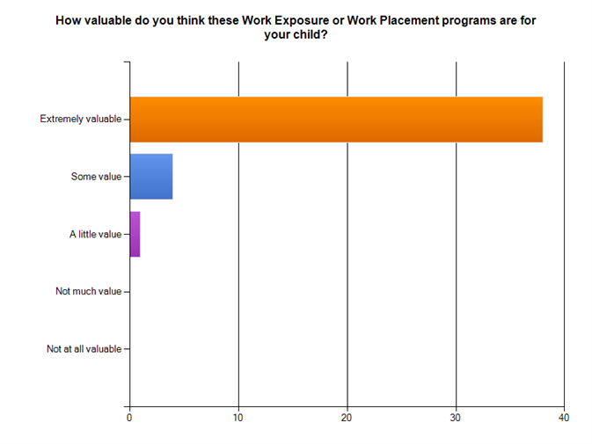
The majority of parents reported that their child made comments to them about the work exposure or work placement activity subsequent to their participation.
75% of parents indicated that the Work Exposure or Work Placement activity that they had participated in were generally enjoyable, informative and valued.
One of the clear themes to emerge from the survey responses was the extent to which engagement with the workplace assisted students to gain a clearer understanding of the skills involved in working in a particular trade, and also in clarifying the differences between occupations in a particular trade. The following comments illustrate the point:
It changed their views of the work involved in the trade they had chosen. (Parent of a Year 11 student)
Very beneficial, he better understood what an Industrial Electrician does compared with what an Electrical Engineer does. (Parent of a Year 12 student)
A second theme was that practical engagement with workplace based activity allowed students to either confirm that they had an interest in pursuing a career in a particular industry, or else to discover that it might not be their preferred path after all.
He really enjoyed the work experience and it confirmed to him that this was the field of work he wanted to go into. (Parent of a Year 12 student)
It helped my son to confirm that he wanted a career in plumbing. (Parent of a Year 10 student)
It established what areas they were interested in and what areas they weren't. (Parent of a Year 12 student)
Another theme to emerge from parental feedback on their children’s comments after involvement in the programs was the value many found in being able to interact with older workers who could assist them. In addition to the acquisition of skills, exposure to occupations and workplaces facilitates the development of knowledge through new relationships and networks.
He liked doing the work placement and liked talking to the other employees to see what they thought of their job and conditions. He especially enjoyed the work places where he was able to have a go and got some hands-on experience and got to learn more about the profession. (Parent of Year 12 student)
Several parents also noted that their children indicated how much they appreciated the opportunity for ‘practical learning’ in the work environment.
Impact of student involvement in Work Exposure and Work Placement
Parents generally consider Work Exposure and Work Placement to have positive effects on their children’s learning and motivation. See Figure 5 below. The strongest impact reported is that their child is ‘more prepared for work’ as a result of their involvement. All parents reported this to be the case.
A second impact that almost all parents reported is that the student is ‘better able to understand their options’ and this is generally linked to a third outcome of being ‘more interested in a career’, although there were a small number of parents who did not feel this had occurred for their child.
The impact on school behavior and performance was less clear-cut than for career options and interest, but a clear majority still indicated that they felt that students were happier and more motivated at school, were attending more regularly, getting into less trouble and completing work more often.
Figure 5: Parent views of the outcomes of work exposure or work placement programs for their child
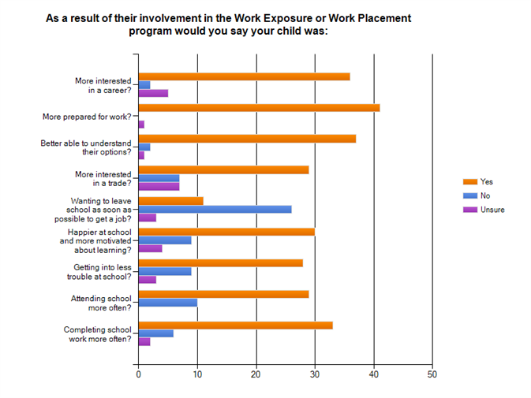
The value of the employer contribution in Workplace Exposure and Work Placement
Children at that age really don't listen to their parents and are often not interested in school anymore so I think an outside employer might actually make the kids understand the realities of going into the workforce and what is involved once they have finished school…..All the things parents and schools have already tried to tell them. (Parent of Year 12 student)
Parents strongly support students learning about the requirements of the workplace directly from employers. Virtually all indicate a belief that this is highly valuable or extremely valuable. See Figure 6 below.
They generally feel that school students are better suited learning about the workplace in a practical environment. Students are reported to take the information more seriously if it is communicated by an employer; and they are generally more receptive to this source of information.
I believe that the child having the information directly from an employer takes it a bit more seriously. (Parent of Year 11 student)
Figure 6: Parent views of the value of learning about work in the workplace compared with only learning at school
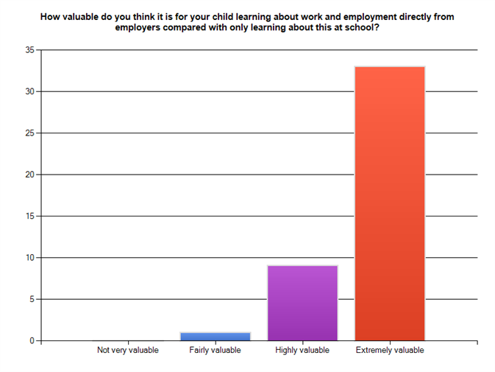
Parent responses also indicate that “hands on” experience is valued over classroom based activities by their children, and also in many cases by themselves.
Some students learn better by having a ‘hands on’ approach rather than just listening in a class. They learn what it is like to be part of the ‘real working world’. More receptive about being told what work is like and what to do rather than by a parent or teacher. (Parent of Year 11 student)
The placement at a workplace benefits my child by seeing the hands on application of the trade. (Parent of Year 12 student)
My child struggles with school paperwork but is great with hands-on learning and is very capable of doing a great job in the workplace without having to have a pen in his hand, so it is valuable to his self-esteem to feel that he is not ‘hopeless and stupid’. I feel the workplace provides everyday real life situations that text books never can. (Parent of Year 12 student)

4 Student Views
Respondents
Thirty-five students, involved with 20 different group training organisations (GTOs) responded to the survey on work exposure and work placement programs involving GTOs. The largest number of respondents was from Year 11 (43%), followed by Year 10 (33%), then Year 12 (23%). Only one respondent was from Year 9. Two thirds of the respondents were male.
Involvement in work exposure or work placement activities
The most common activity that the students said they had undertaken was short term work experience (75%), followed by a school-based apprenticeship or traineeship (66%). However most had also been involved in career expos, visits to workplaces and career education programs.
Students were mostly aware of GTO involvement in activities related to school-based apprenticeships and traineeships, short term work experience, career expos and assistance with learning how to apply for a job.
Usefulness of work exposure activities
Students found the most useful programs to be short-term work experience, visits to workplaces and assistance with learning how to apply for a job. Most students considered each of these activities as ‘very useful’, with short-term work experience being considered ‘very useful’ by 80% of respondents. See Figure 7 below.
Figure 7: Students views on usefulness of work exposure activities
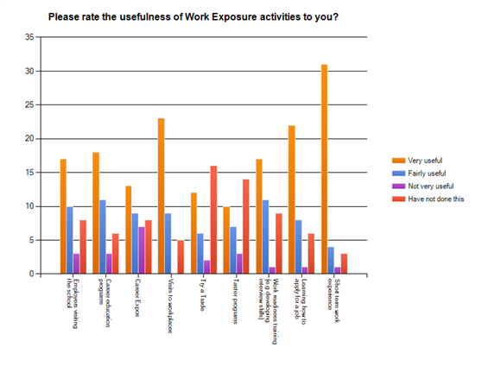

Benefits in learning about work from an employer
‘Hands-on’ was the most common term students used when asked about the value of learning involving employers. A number of Year 12 students said they valued the realistic, practical experience, as opposed to just hearing about the theory.
It allows you to be hands-on and actually do all the things that you want instead of just reading about it in books.
Hands-on experience in the workplace is so much more effective.
More hands-on rather than theory based.
A number of Year 11 students felt that information coming from an employer is more useful and believable because employers have first-hand experience.
You feel like it is more useful and more direct from someone in the area of work.
Employers have real knowledge and skills.
The person in the workplace knows a lot more than the teacher and has actually experienced it.
The school will only know a brief overview or amount compared to that of the employer who will know all the 'nooks and crannies' of the job.
Several students also valued having the opportunity to see for themselves what was required in the workplace, rather than relying on what they’d been told.
Because you are in the workplace and working you can see what the employers need, not just get told from the classrooms. (Year 10 student)
Usefulness of work placement activities
The most useful work placement activities from the student’s point of view were being mentored by an employer or an employee in the work place and undertaking a school-based apprenticeship or traineeship. 72% of students who had been mentored considered it extremely valuable. 71% of students who had undertaken a school-based apprenticeship or traineeship said it was ‘extremely valuable’, a further 16% said it was ‘highly valuable’. Structured work placements were considered ‘extremely valuable’ by 58% of students who had tried them, and considered ‘highly valuable’ by a further 25%. See Figure 8 below.

Figure 8: Student views of the value of a range of work placement activities
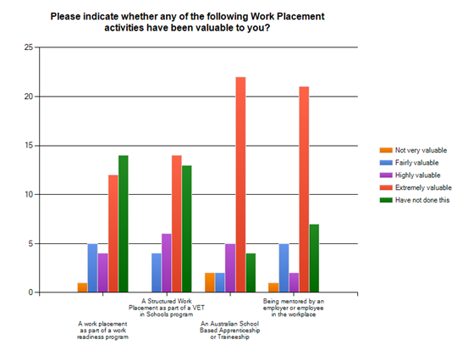
Almost all students who had undertaken a work placement felt it was long enough to develop some useful skills. A couple of students felt that they would have liked a little longer in the workplace.
I found that by the time you had learnt everything it was time to begin a new placement or it had finished. I think a longer period of time would have been better. (Year 11 student)
Students were asked what was the most valuable thing about working with an employer in a work placement.
Again, students said they valued getting real life experience and a true understanding of the nature of the job. A number of Year 11 students said:
I didn't realise all the different parts of the job. Being a tradesman is a lot more involved than I thought - the job would be more interesting than I first thought.
Life in the real world outside school.
You found out exactly how it would be in the workplace.
Learning how to do things correctly, directly from the experts, was also considered important. A number of Year 10 students enjoyed the people aspect - building relationships in the workplace, interacting with people, and having access to people to listen to and explain how to do things.
The employer can tell you first-hand what goes on behind the scenes and the answers are sure to be true because they know just what happens.
My employer tells me how to do it and do it properly and that is how I learn.
You are always interacting with everybody at the place.
A few students benefited from being offered opportunities to be put on as an apprentice or trainee
I liked my placement, and they liked me, and they are thinking of putting me on as a school-based apprentice as a hairdresser. (Year 10 student)
Preparation for work placements
Just over two thirds of respondents received preparation for work placements. Thirteen percent said they did not receive any preparation and 23% were unsure whether they received preparation.
Of those that were aware they received some preparation, half said that the school provided the preparation, a third said the GTO provided preparation. The others said it was both the GTO and the school who provided the preparation or it was provided by the host employer.
Outcomes from the program
All except one of the student respondents achieved a positive outcome from the program. The vast majority of students (83%) felt they were more prepared for work as a result of the program and more than two thirds became more interested in a career. Seventy-percent said they decided to pursue an apprenticeship or traineeship after their work placement activity. Over a third (14) students decided to continue at school as a result of the program, while six said they had changed their mind about continuing at school and planned to leave to get a job. See Figure 9 below.
Figure 9: Student views on outcomes from their work placement
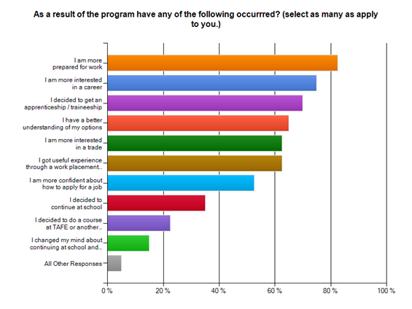
More than half of the students said that as a result of participating in work exposure or work placement activities they feel happier at school and more motivated. 38% said they complete class work more often and 30% said they come to school more often and complete homework more often. See Figure 10 below.

Figure 10: Student views on attitudinal changes as a result of work placement and work exposure programs
